Maestro Internet Access

- Open an internet browser
- Type https://maestro.drivebudget.com into the Address field
- As the password prompt pops up, enter
User Name: 06yvr15a
Password: lic378
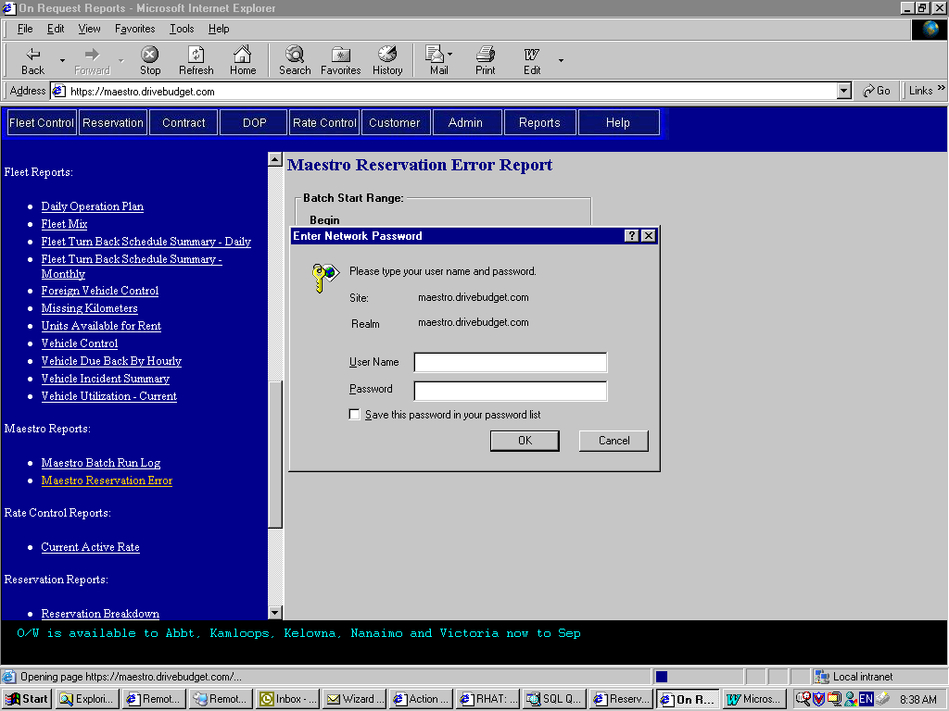

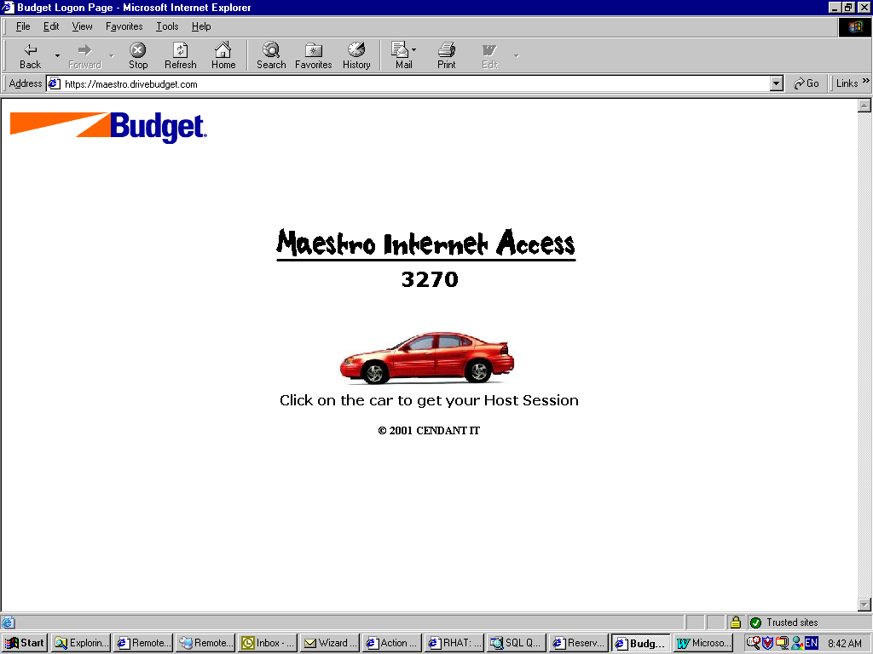
- After logon, it will bring you to the Maestro main page.

- Click on the red car picture to get the Maestro terminal screen.
- It takes a few minutes before the Maestro terminal will pop up.
- Type in bims, when see the message “VTAM….”. Then Enter.
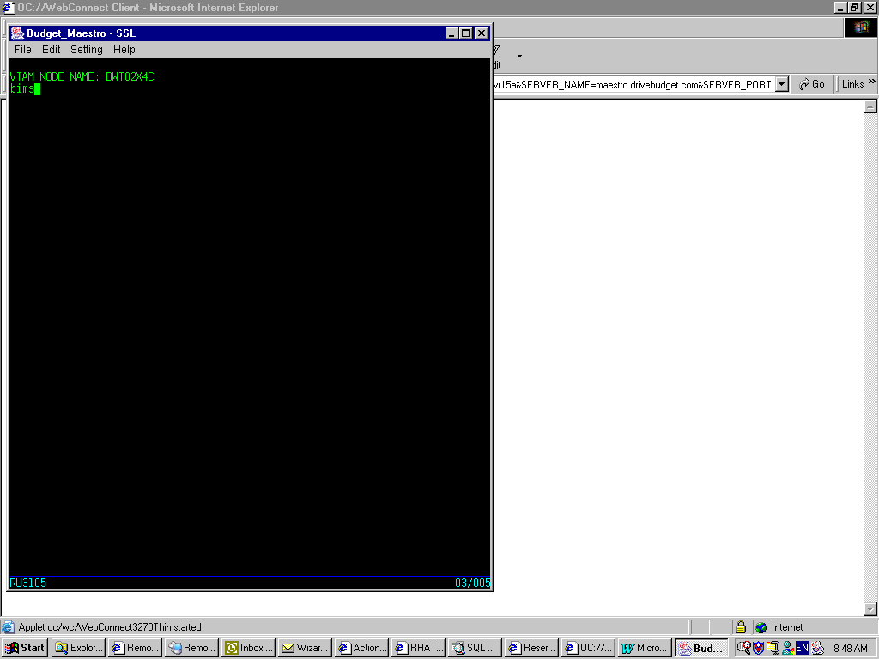

- In the system logon screen, enter
USERID: s742502a
PASSWORD: yvr469 (hidden)

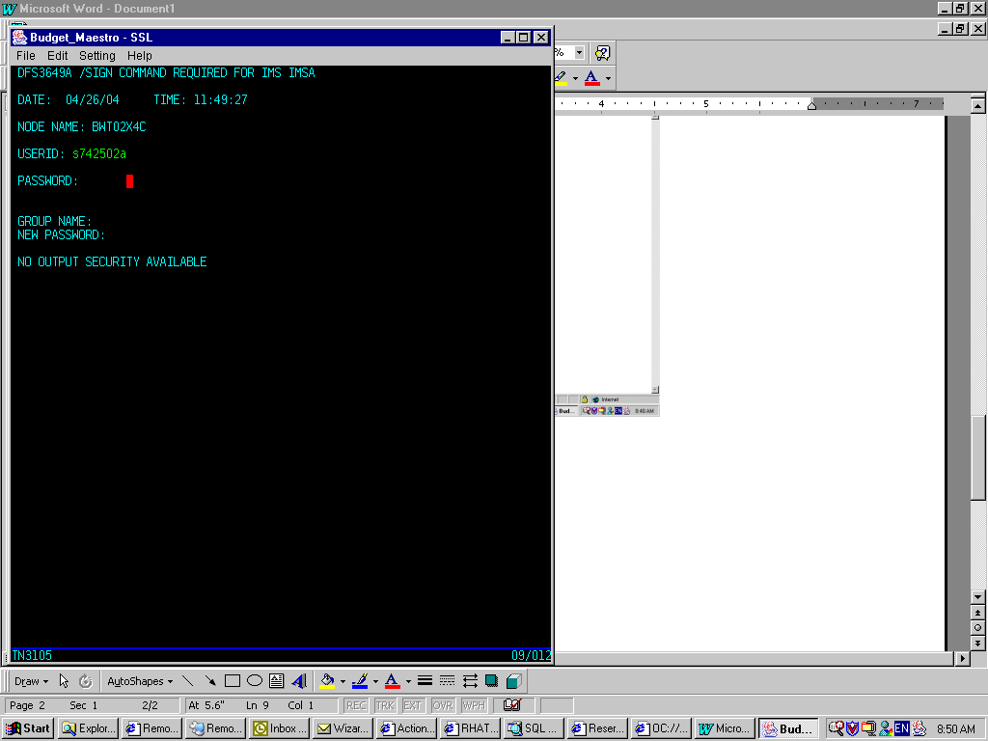

- Enter command to go to different Maestro screens. For instance, to view reservation, enter /for b502.

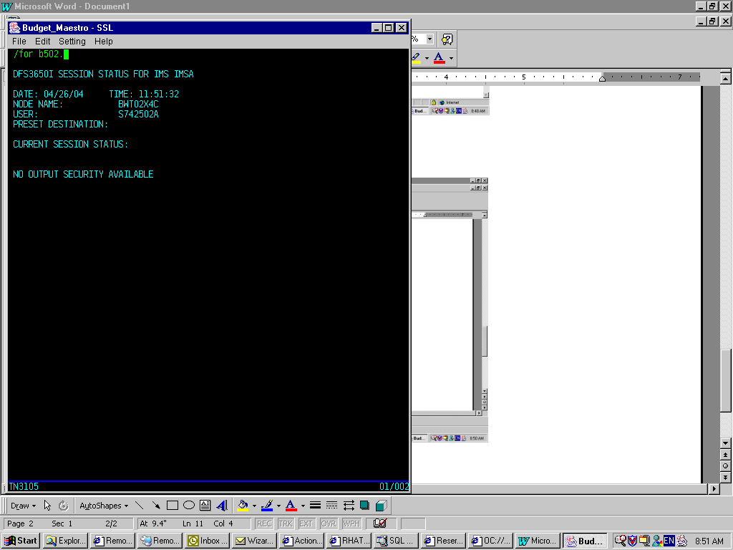

Print b502 report

- Type /for b502. to go to reservation screen.
- Type qr or dr in the first field at the left handed top corner.
- In the NAM field, type in r/maestro_rez_num.

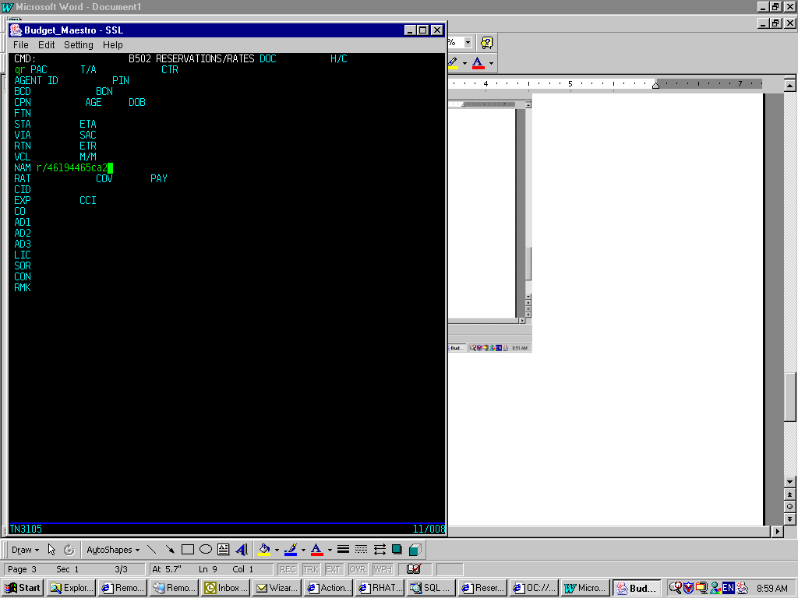
- Press Enter to retrieve reservation.
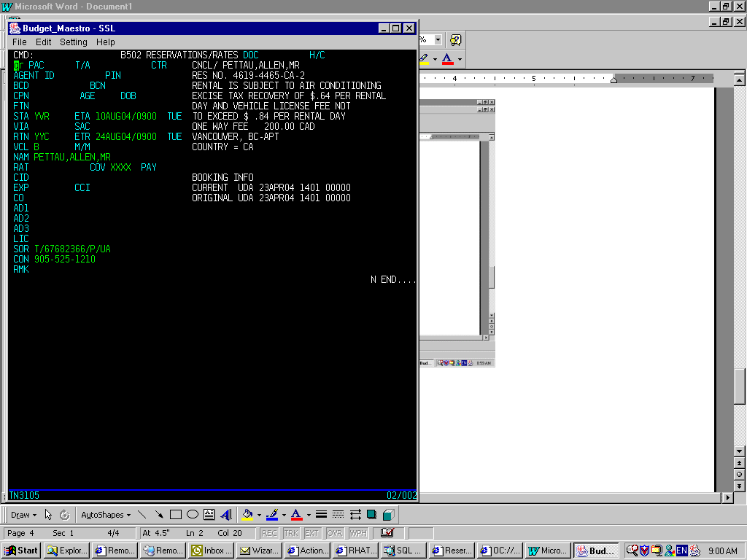

- Verify the confirmation number on the right-handed top corner. Sometimes, Maestro will display an old reservation, press enter again to re-submit the command.

Log off Maestro terminal

Note: Always remember to log off Maestro terminal properly before you close all browser. This helps to avoid displaying old reservation.

- Press Home to go to the CMD field.
- Type /end. and press Enter.
- Wait for the message “…END COMMAND COMPLETED”, then you can close the browser.

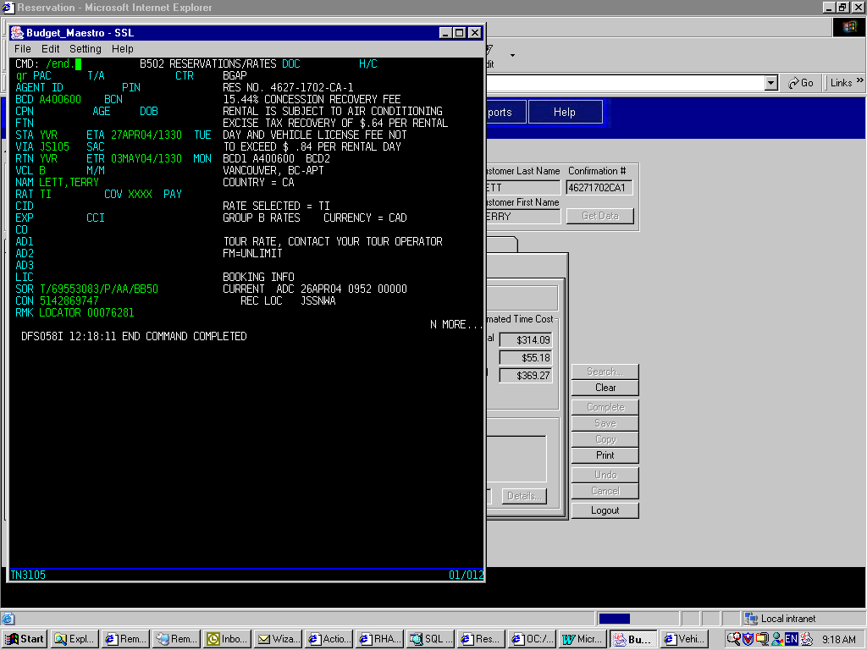
- Or you can type /rcl to clear the current session and go back to the VTAM screen to re-logon again.
- Whenever Maestro does not work properly, end the session (/end.), clear it (/rcl.) and re-logon.

Tips

- P: After I logon, I cannot go to the b502 screen or any other screens.
S: Use /end. and /rcl. respectively to end and clear the session properly, then re-logon again.

- P: When try to retrieve a reservation, another reservation is displayed instead.
S: Press Enter again. If it still does not work, end, clear session and re-logon again.

- P: I was being very fast and keep typing some keys or Enter. However, there is no response and
whatever I type does not display.
S: Check the status bar at the bottom of the screen. If you see the message “…X WAIT”, it means the system is busy and please wait. Wait until the message disappears before you continue typing. If problem persists, check the network.

- To advance to next page, use Ctrl + F1 keys.
- To print screen, go to File/Print Screen.
- To copy, select text and go to Edit/Copy. In this case, Ctrl + C will not work.

